Jonathan Yang

Assignment 2

Birthday Class

**Test Case 4**

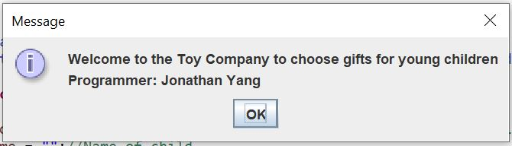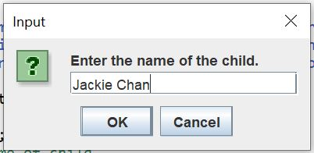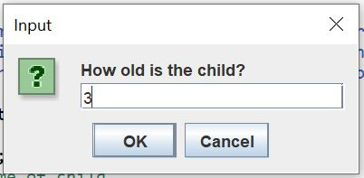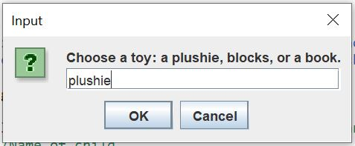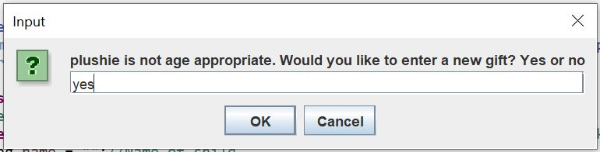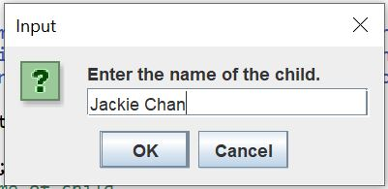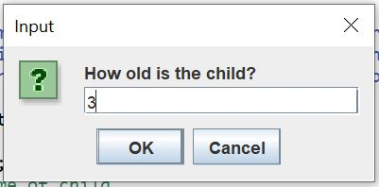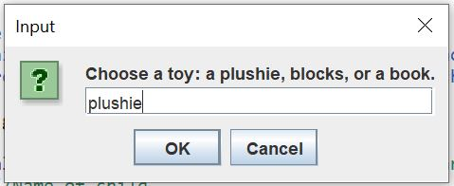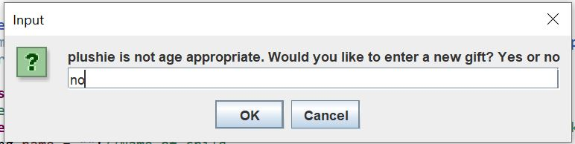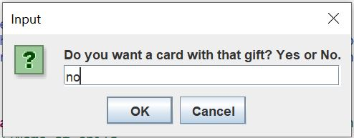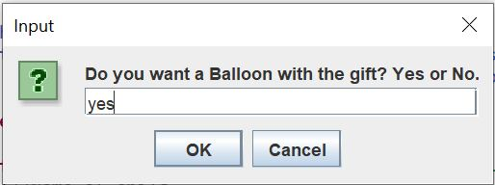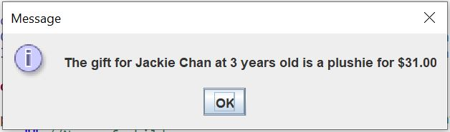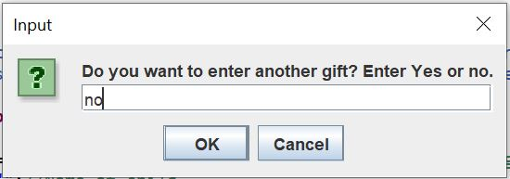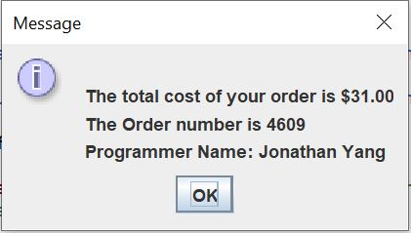

|  |  |  |  |  |  |
| --- | --- | --- | --- | --- | --- |
| Test Case # | Input | Actual Input | Expected Output | Actual Output | Did the test pass? |
| 4 | Name:  Jackie Chan  Age:  3  Toy:  Plushie  Cards:  No  Balloon:  Yes | Name:  Jackie Chan  Age:  3  Toy:  Plushie  Cards:  No  Balloon:  Yes | Age Ok:  No  Total Cost:  31.00 | Age Ok:  No  Total Cost:  31.00 | Yes |